2.5" External SATA Hard Disk ENCLOSURE

Simply Add Your Own 2.5" Hard Disk
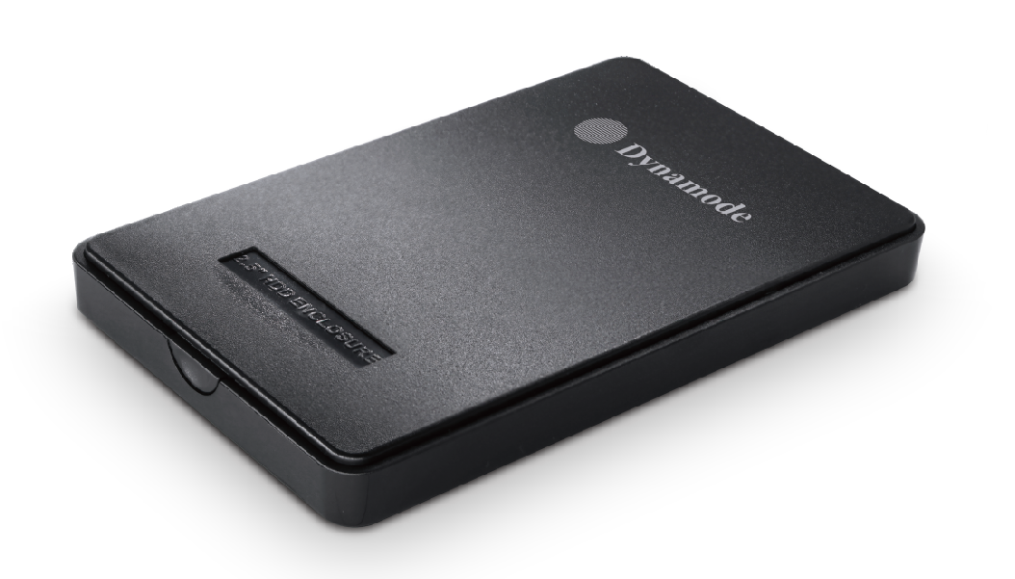

DESCRIPTION
Are you looking for a high-performance but fully backward compatible external hard disk enclosure for your desktop, notebook or other computing device? Do you need the extra data transfer performance that USB3.0 can give you for streaming movies without buffering or copying large digital images to and from your computer?
The USB3-HD2.5S-SH1 is your ideal portable storage enclosure. Featuring a SuperSpeed USB3.0 interface which transfers data around x10 quicker than standard USB2.0. And if your computer only has USB2.0 at the moment, no problem, the enclosure is fully backward compatible with USB2.0 if required.
Easy to install, just plug in your existing 2.5" SATA hard disk, connect up the supplied hard disk into the easy-fit enclosure, connect up the supplied USB2.0/USB3.0 data cable and start copying your data. No need for an external power supply, as its self-powered by the data cable.
Fully Plug and Play with leading Operating Systems including Windows10TM and MacTMOS X.

FEATURES
Backward compatible with USB2.0
Stylish, portable and compact design
Ideal for your existing 2.5" SATA interfaced hard disk drives
Re-use your PC, Server or Mac hard disk and keep your data when you upgrade
Plug'n Play for popular Operating Systems - no drivers needed
No external power supply required
Backup and restore your data at up to 5Gbps

SPECIFICATIONS
